Deficits negatively impacting comprehension in ASD

- Theory of mind (ToM) refers to the ability to understand others’ point of view or perspective:
- Ability to understand the characters’ feelings in a text and relate those feelings to their own. Without ToM, students with ASD struggle with understanding the idea that people have thoughts other than their own, understanding situations from others’ perspective, and predicting behavior based upon context.
- Central coherence is the ability to bring details together into a whole concept or idea.
- Ability to identify the major theme of these texts or genres (e.g., fiction, nonfiction). Students with ASD may demonstrate weak central coherence (WCC), or the inability to bring details into a central concept or context.
- Executive functioning (EF) refers to the process of organizing, planning, and monitoring progress when presented with a situation.
- Ability to describe various aspects of a story using details such as characters and settings. EF deficits in students with ASD might influence their ability to engage in:
- organizing (i.e., sequencing the events of a story)
- planning (i.e., accessing prior knowledge, making connections), and
- monitoring their comprehension (i.e., creating mental images, engaging in discussions, summarizing).
Reading comprehension is a covert activity (i.e., the process of understanding reading texts occurs inside students’ minds). Therefore, it is paramount for teachers to intentionally use strategies to determine and be able to observe, overtly, the level of understanding students have on the topic (Roberts, 2013).

Interventions should focus on ways in which general educators can overtly observe the students’ comprehension of the text. See article below to see how educators can teach students with ASD to comprehend daily reading texts at a basic level.

Reference:
Nguyen, N. N., Leytham, P., Schaefer Whitby, P., & Gelfer, J. I. (2015). Reading comprehension and autism in the primary general education classroom. The Reading Teacher, 69(1), 71-76.

Affects are either positive, neutral, or negative
Positive affects
- Interest-Excitement – pull towards mastery
- Enjoyment Joy – The social bond
Neutral affect
- Surprise-Startle
Negative affect
- Distress-Anguish
- Anger-Rage
- Fear-Terror
- Shame-Humiliation
- Disgust
- Dismell

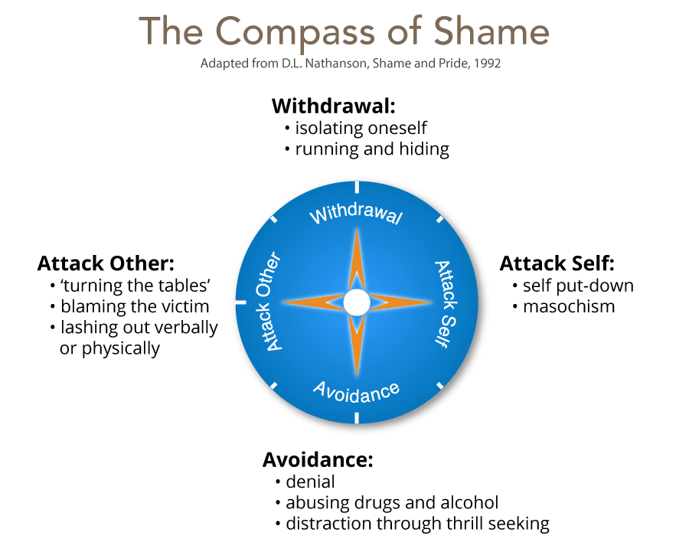

Learning shame: pupils can
- withdraw (switch off from learning and not attend lessons),
- attack self (put themselves down, assume they are dumb)
- avoid (be the class clown, focus on other aspect of their lives, take risks, use drugs etc), or
- attack other (put others down, belittle value of work, diminish someone, bully others).

Cognitions, affects, and behaviours associated with mindset
- Pupils have certain self-theories about their ability and have a set of scripts around learning.
- Mindset – shame affect is central to complex learning.

- Fixed mindset:
- Fixed mindset – that, capabilities are fixed since they are part of the self and the self is fixed and constant. Attributes success to innate qualities of the self and sees failure as evidence that the Self is faulty (shame prone). THE WORLD IS ABOUT MEASURING YOUR ABILITY. IT IS A WORLD OF THREAT AND DEFENCES.

- Stimulus = Challenge = self-doubt, helplessness
- Affect = distress, fear, anger, shame
- Behaviour = risk avoidance, defensiveness, competitiveness, withdrawal hostility, lying.

- Growth mindset:
- Growth mindset: believes capabilities can be developed through effort, i.e through behaviour. Attributes success to effort and behaviour and sees failure as a need to work and study harder (guilt prone). THE WORLD IS ABOUT LEARNING AND GROWTH. IT IS A WORLD OF OPPORTUNITIES TO IMPROVE.

- Stimulus = Challenge = self-confidence, aspiration
- Affect = interest-excitement, enjoyment joy
- Behaviour = high effort, challenge-seeking, cooperativeness, persistence.

Cognition and learning and emotional regulation (mindset). Considerations
- Desire/motivation for learning:
- is learning about looking smart in every situation, proving himself and never failing, or
- is it about taking risk, learning, and thriving on challenges?
- How does he evaluate situations?
- Does he think of challenges in terms of success or failure, looking smart or dumb, or
- Does he see tasks as opportunity to grow and/or help him do better in future.
- How does he deal with setbacks?
- Does he attribute setbacks as him being a failure (self-identity) – shame-like, I can’t do this (attack self), or
- to his behaviour - I failed (behaviour – guilt-like), I need to try harder, do things differently.
- How does he perceive change?
- avoids challenges, get defensive, or give up easily (compass of shame), or
- embrace challenges, persist in the face of setbacks (employs interest)
- How does he perceive effort?
- thinks effort indicates low intelligence, or
- that growth and learning require effort?
- How does he take criticism?
- ignore constructive criticism, it can’t help, or,
- learn from it, how can I improve?
- How does he perceive success of others?
- feels threatened by others success (shame affect), or
- finds lessons and inspiration in others success.

These determines Outcome: achieve less than full potential or reach ever higher levels of achievement.

What to do
- Through empathic intervention recovery strategies can be modelled to trigger interest and excitement where shame was previously triggered. Focus on the behaviour is more adaptive (guilt like response). It triggers interest-excitement affect that leads to understanding and learning that produce enjoyment-joy from success.
- Needs supportive teacher, praise his efforts, and gently guide his work. High expectations and belief that he can do the work. Revise his script for failure.

Promote a growth mindset
- Establish high expectations (not just high standards).
- Create a risk-tolerant learning zone.
- Give feedback that focuses on process – things that he can control.
- Focus on how tasks/activities are framed and how feedback is provided.
Framing tasks
- Example of communicating learning goals: we are in the learning zone today; mistakes are our friends!
Communicating high expectations
- Example of communicating high expectations: As you learn this, mistakes are expected. Your mistakes help me to support you. Let’s make mistakes together!
Giving feedback:
- example of when he struggles despite strong effort: I admire your persistence and I appreciate your hard work. It will pay off!
- Example of when he struggles and needs help with strategies: Let’s do one together…
- Example of when he is making progress: I see you using your strategies/tools/notes etc. keep it up!
- Example of when he succeeds with strong effort: I am very proud of you for not giving up and look what you have to show for it!

